**In order to achieve the assessment criteria (P6) you must answer the following task:**

**Task 1**

Explain briefly the following types of programmable logic devices:

* PAL.
* GAL.
* CPLD

**(P6)**

**In order to achieve the assessment criteria (P7) you must answer the following task:**

**Task 2**

Evaluate the following sequential circuits in figure 1 and figure 2

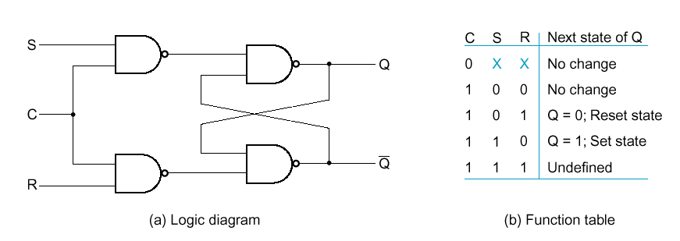

Fig (1)

*Q*0



Clear

*Q*1

*Q*2

*Q*3

Clock

Fig (2) **(P7)**